Table of Contents

Table of Contents 1

CHAPTER 1 3

1.1. Introduction 4

1.2. Problem statement 5

1.3. Proposed Solution 6

1.4. Project Objectives 7

1.5. Project scope 8

1.6. System significance 9

CHAPTER 2 10

2.1. About Dar AL-Fajr for The Care and Rehabilitation of Orphans 11

2.2. Existing System 12

2.3. Examples of the similar existing systems 12

CHAPTER 3 15

3.1. Introduction 16

3.2. Development Plan 16

3.3. Feasibility Study 17

3.3.1. Economically feasibility 17

3.3.2. Operational feasibility 17

3.3.3. Technical feasibility 17

3.4. Requirement Specification 18

3.4.1. Functional Requirement 18

3.4.2. Non-Functional Requirement 18

CHAPTER 4 20

4.1. Introduction 21

4.2. Use Case Diagram 22

4.2.1. Admin Use Case Diagram 23

4.2.2. Orphan’s Guardian Use Case Diagram 24

4.2.3. User Use Case Diagram 25

4.2.4. House supervisor Use Case Diagram 26

4.2.5. Health Supervisor Use Case Diagram 27

4.2.6. Activity Supervisor Use Case Diagram 28

4.2.7. Educational Supervisor Use Case Diagram 29

4.2.8. Social Specialist Use Case Diagram 30

4.3. Use Case Specification 31

4.4. ER Diagram 33

4.5. Class Diagram 34

4.6. Data Dictionary 34

4.6.1 Table User 34

4.6.2 Table Boarding House Supervisor 34

4.7. Sequence diagram 34

CHAPTER 1

INTRODUCTION

## Introduction

Technical management of boarding house at Dar AL-Fajr for The Care and Rehabilitation of Orphans is a subsidiary house for AL-Fajr Foundation for Orphans Care and they are responsible for managing the boarding house. The boarding house houses 63 orphans who are being fully cared “financially, socially, healthily”. The house sponsors orphans from the first grade to ninth grade. Also, the house includes many courses and educational programs which aims to raise the capabilities of the orphans and make them adapt to life and society. Moreover, orphans are divided in the house into four wings and every wing includes 15 to 16 orphans. And orphans are divided in wings according to certain criteria like: school year, age, health status and behavior. Moreover, orphans receive their education through different schools in AL-Mukalla city. Beside that orphans are registered as attended on Saturday and they stay in the boarding house to Thursday. And from Thursday afternoon to Saturday afternoon, they can go to their houses or relatives. Also, orphans can leave the boarding house between the two semesters and in the end of the school year. In addition, every year the boarding house accepts new orphans based on interviews and certain procedures. Beside that each orphan is prepared for 7 to 10 days to monitor his behavior and social activity. Finally, the house cannot accept orphans with special needs because they do not have the ability to provide the care they deserve. Also, the house has a health clinic with a doctor and a clothes washer and cleaning employees.

## Problem statement

Dar AL-Fajr for The Care and Rehabilitation of Orphans management state the following problems:

1. **The difficulty of accessing or editing orphans’ information**: Because orphans’ information registered manually. search process of an orphan information requires a lot of efforts and time.
2. **Complexity of orphan’s evaluation process**: Since there are many factors and employees are involved in the evaluation process the evaluation result could take longer time also the evaluation could be wrong.
3. **The difficulty of keeping track of orphan’s health information**:
4. **The difficulty of accessing or editing sponsor’s information and sponsorship information**.
5. **The difficulty of managing activities**: manager divides the year activities to quarters every quarter have an activities of three months. The process of dividing the activities into quarters is complex and if there are any changes the editing is more complex.
6. **The difficulty of generating reports**: generating reports require a search about orphans, sponsors and activities information.
7. **The difficulty of managing orphans’ attendance**: The attendance is performed in the first day of the week “Saturday “if the orphan is absent on Saturday, then he will be absent for the whole week. But if he attends in the middle of the week he will be registered as if he attends from the first day.
8. **Damage or Loss of papers**:

## Proposed Solution

The purpose of this project is to convert the system used in Dar AL-Fajr for The Care and Rehabilitation of Orphans from manual system to a computerized system. OAMS will be developed to make user of the system able to perform the following operations in easy and effective way:

1. Manage orphans’ information.
2. Display information of orphans, sponsors and activities clearly.
3. Keep track of orphans’ behavior.
4. Manage activities.
5. Manage orphans’ attendance.
6. Orphans’ evaluation.

## Project Objectives

1. Display and manages orphans, sponsors, and activities information in clear and effective way.
2. Reduce the use of paper by computerizing the system.
3. Easily evaluate orphans’ behavior and activities execution.
4. Manage orphans’ attendance in accurate and clear way.
5. Enhance management performance.

## Project scope

OMAS will be developed for developed for Dar AL-Fajr for The Care and Rehabilitation of Orphans boarding house. And it is only concern with orphans and activities operations like orphan registration, keep tracking behavior health and school information and orphan evaluation. Also, activity division and evaluation and generate the related reports. The employee and financial management are out of our scope.

## System significance

1. Facilitate the management work.
2. Provide detailed information about orphans’ sponsors and activities.
3. Keep track of orphan behavior and activities execution.
4. Make the management able to focus in improving their services rather than just management.

CHAPTER 2

Existing system

## About Dar AL-Fajr for The Care and Rehabilitation of Orphans

Dar AL-Fajr for The Care and Rehabilitation of Orphans …………….

.

.

.

……………………………..IMGs…………………

## Existing System

Technical management of boarding house at Dar AL-Fajr for The Care and Rehabilitation of Orphans currently use manual system for managing the boarding house. However manual system has many drawbacks in storing data effectively, the weakness in protecting this data, and the difficulty of searching for monthly and annual reports for orphans and activities. And the complexity of evaluating orphans and activities.

## Examples of the similar existing systems

There are different Orphans management systems, which produced by specialized companies. These systems do not fully match the requirements of Technical management of boarding house at Dar AL-Fajr for The Care and Rehabilitation of Orphans.

1. Heroes Association system for the care of orphans

Heroes Association system for the care of orphans is an orphans management system used in Heroes Association for the care of orphans in Saudi Arabia. It is a desktop system used for managing orphans, sponsors, and families in need. Also, it used in managing sponsors payments. This system does not cover all requirements of management of boarding house at Dar AL-Fajr for The Care and Rehabilitation of Orphans.

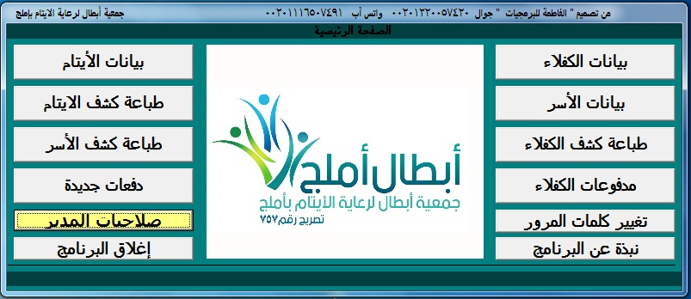

1. Orphanage management system

Orphanage management system is a system used to manage an orphanage. It is a desktop system used for manage orphans, family in need and people with disabilities. This system is general system and does not cover all operations in an orphanage. Also it has a static UI and do not provide any information about orphans or orphanage

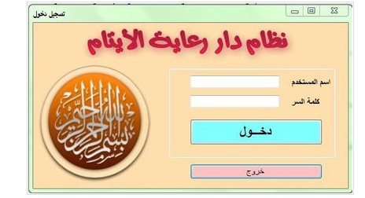

CHAPTER 3

Methodology

## Introduction

## Development Plan

## Feasibility Study

### Economically feasibility

OAMS that will be developed will be economic concerning Dar AL-Fajr for The Care and Rehabilitation of Orphans point of view. It is cost-effective in the sense that it has eliminated the paperwork. The system will be time effective because the calculations are automated and are made to the user's requirement. The result contains minimum errors and is highly accurate as the data is required.

### Operational feasibility

OAMS is easy to use and learn due to its simple attractive interface. Users do not require special training to operate the system.

### Technical feasibility

Technical feasibility study analyst focuses on the hardware and software requirements, such as suggested input devices that can enter a large amount of data in a specific time. Output devices can produce a large amount of data in a particular time and match output into proper input. It also focuses on the availability of resources required, such as programmer tester. For developing OAMS, all needed technologies currently exist at the Dar AL-Fajr for The Care and Rehabilitation of Orphans.

## Requirement Specification

In this section, the system requirements specifications are discussed. It is also known as software requirements specifications. For this study, requirements specifications of OAMS consist of:

### Functional Requirement

Functional requirements of OAMS explain what has to be done by identifying the necessary task, action or activity that must be accomplished. The functional requirements of the system include the following:

1. Login.
2. Manage orphan info.
3. Manage sponsor info.
4. Manage activity info.
5. Manage orphan behavior info
6. Manage orphan health info.
7. Mange orphan academic info.
8. Manage orphan attendance info.
9. Manage orphan evaluation.
10. Manage activity evaluation.
11. Reports.

### Non-Functional Requirement

Non-functional requirements specify the quality attribute of a software system. It judges the software system based on Responsiveness, Usability, Security, Accuracy, and other non-functional standards that are critical to the success of the software system.

* **Security Requirements**

Security is important in OAMS since data will be stored in the database. User validation will be done during login to ensure that only authorized users can access the information. And the password is encrypted.

* **Performance**

the website load time should be less than three seconds to the users. The programming language that is used support multithreads.

* **Usability**

The website’s interface has to be user-friendly, easy to use, and convenient for the user.

* **Accuracy**

100% of accuracy is required. The system should provide an accurate real-time report.

CHAPTER 4

System Analysis and Design

## Introduction

Designing is the essential phase of software development, such that planning, and thinking are two necessary techniques before software development. Scheming or planning software means designing how the different parts of the software will achieve the target mission. such that if the phase contains any error, then response time and so on.

System analysis and design concern with the design of (Use case, E-R, Class, Sequence Diagrams).

## Use Case Diagram

Use case diagram model behavior within a system and helps the developers understand of what the user requires.

* The purpose is to show the interactions between the use case and actors.
* To represent the system requirements from user’s perspective.
* An actor could be the end-user of the system or an external system.

A use case is a description of set of sequence of action. Graphically it is rendered as an ellipse with solid line including only its name. use case diagram is a behavioral diagram that shows a set of use case and actors and their relationships. It is an association between the use cases and actors. An actor represents a real-world object. A use case diagram displays the relationship among actors and use cases. The two main components of a use case diagram are use cases and actors.

**Actor:**

A coherent set of roles that users of the use case play when interaction with the use cases.



**Use case:**

A description of sequence of action including variants, that a system perform that yields an observable of value of an actor.



### Admin Use Case Diagram

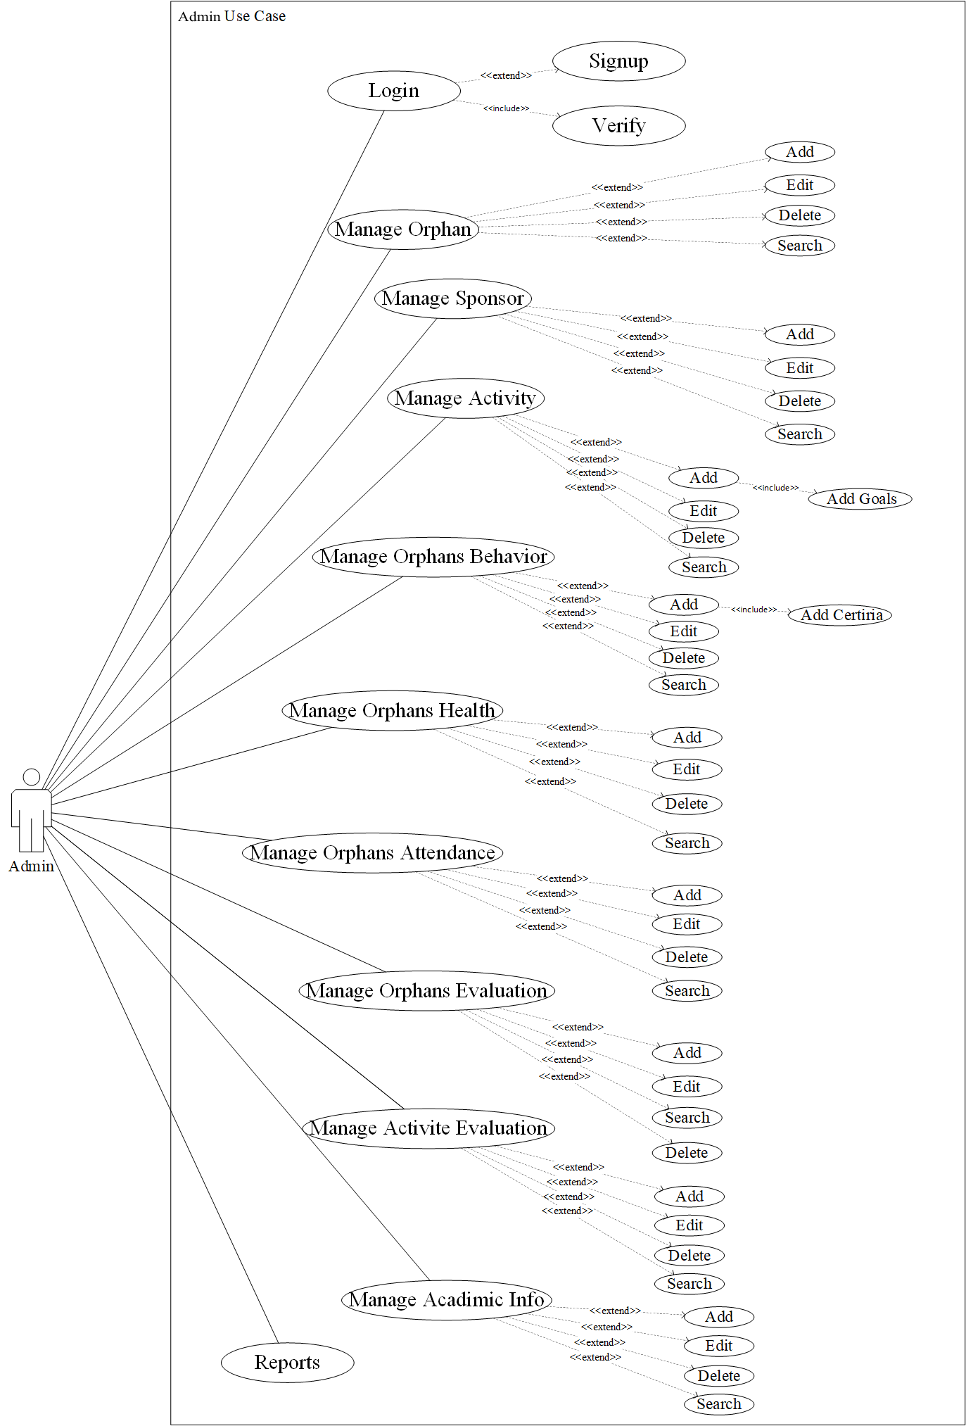

Figure 4.: Admin Use Case Diagram

### Orphan’s Guardian Use Case Diagram

### User Use Case Diagram

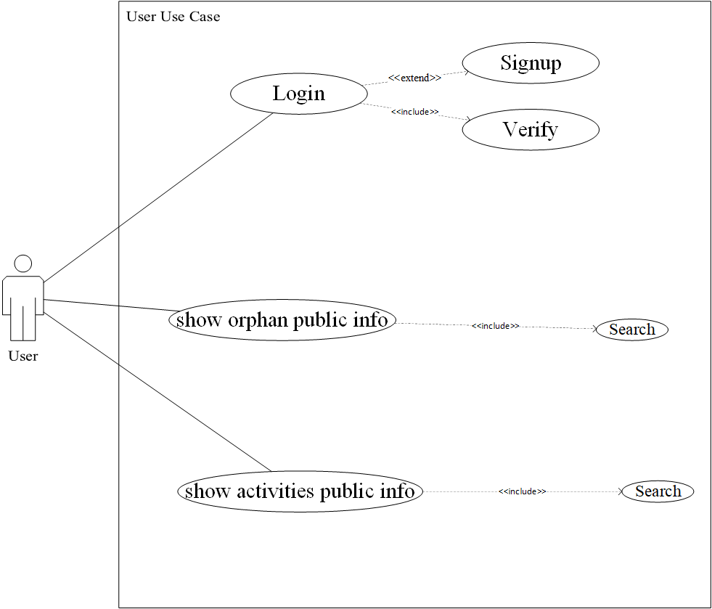

Figure 4.2: User Use Case Diagram

### House supervisor Use Case Diagram

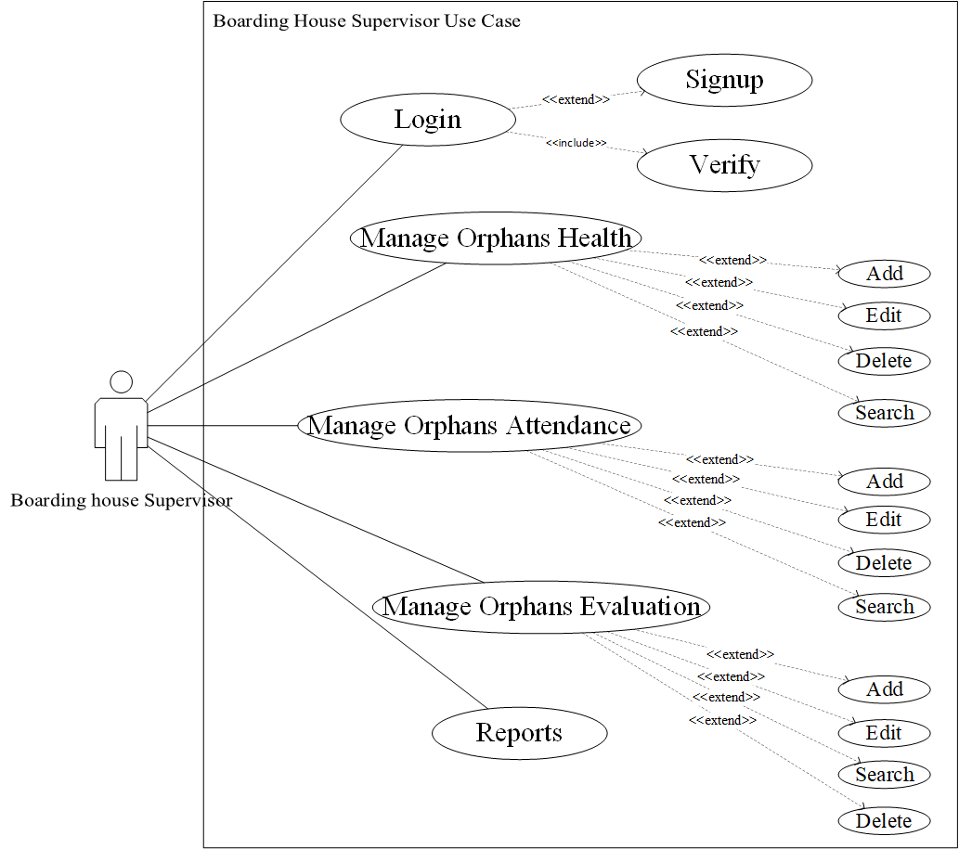

### Health Supervisor Use Case Diagram

### Activity Supervisor Use Case Diagram

### Educational Supervisor Use Case Diagram

### Social Specialist Use Case Diagram

## Use Case Specification

Use case specification is known as Use Case Description. The Use Case Specification includes:

* **Brief Description:** Summary of a use case.
* **Pre-Conditions:** List all the conditions that must be completed before entering the use case.
* **Characteristic of Activations:**  This shows how to activate the use case.
* **Basic Flow:** Describes the normal flow of the use case.

1. **Login Use Case: (User)**

**Brief Description**

This use case is entailed by the users. It will enable the users of the system to explore the system.

**Pre-Condition**

The user must have username and password and must be active.

**Basic Flow**

|  |  |
| --- | --- |
| Actor | System |
| 1. This use case begins when the user connects to the system. |  |
|  | 2. The system displays the login form. |
| 3. The user enters the user's name and password. |  |
|  | 4. The user clicks login button. |
| 5. The system verifies the entered information. (E-1 username or password is invalid). |  |
|  | 6. The system shows the main page. |

Table 4.1 Basic flow of Login Use Case

**Alternative Flow**

No alternative ways.

**Exceptional Flow**

E-1: Username or password is invalid after three times. Here in the system gives a massage to solve the clear problem.

**Post Conditions**

The user has access to the system.

1. **Use Case (manage orphans, manage sponsors, manage activities, manage orphan behavior, manage orphan health info, manage academic info, manage attendance info, manage orphan evaluation, manage activity evaluation, Reports)**

**Brief Description**

…………….

**Pre-Conditions**

……………..

**Characteristic of Activations**

……………..

**Basic Flow**

## ER Diagram

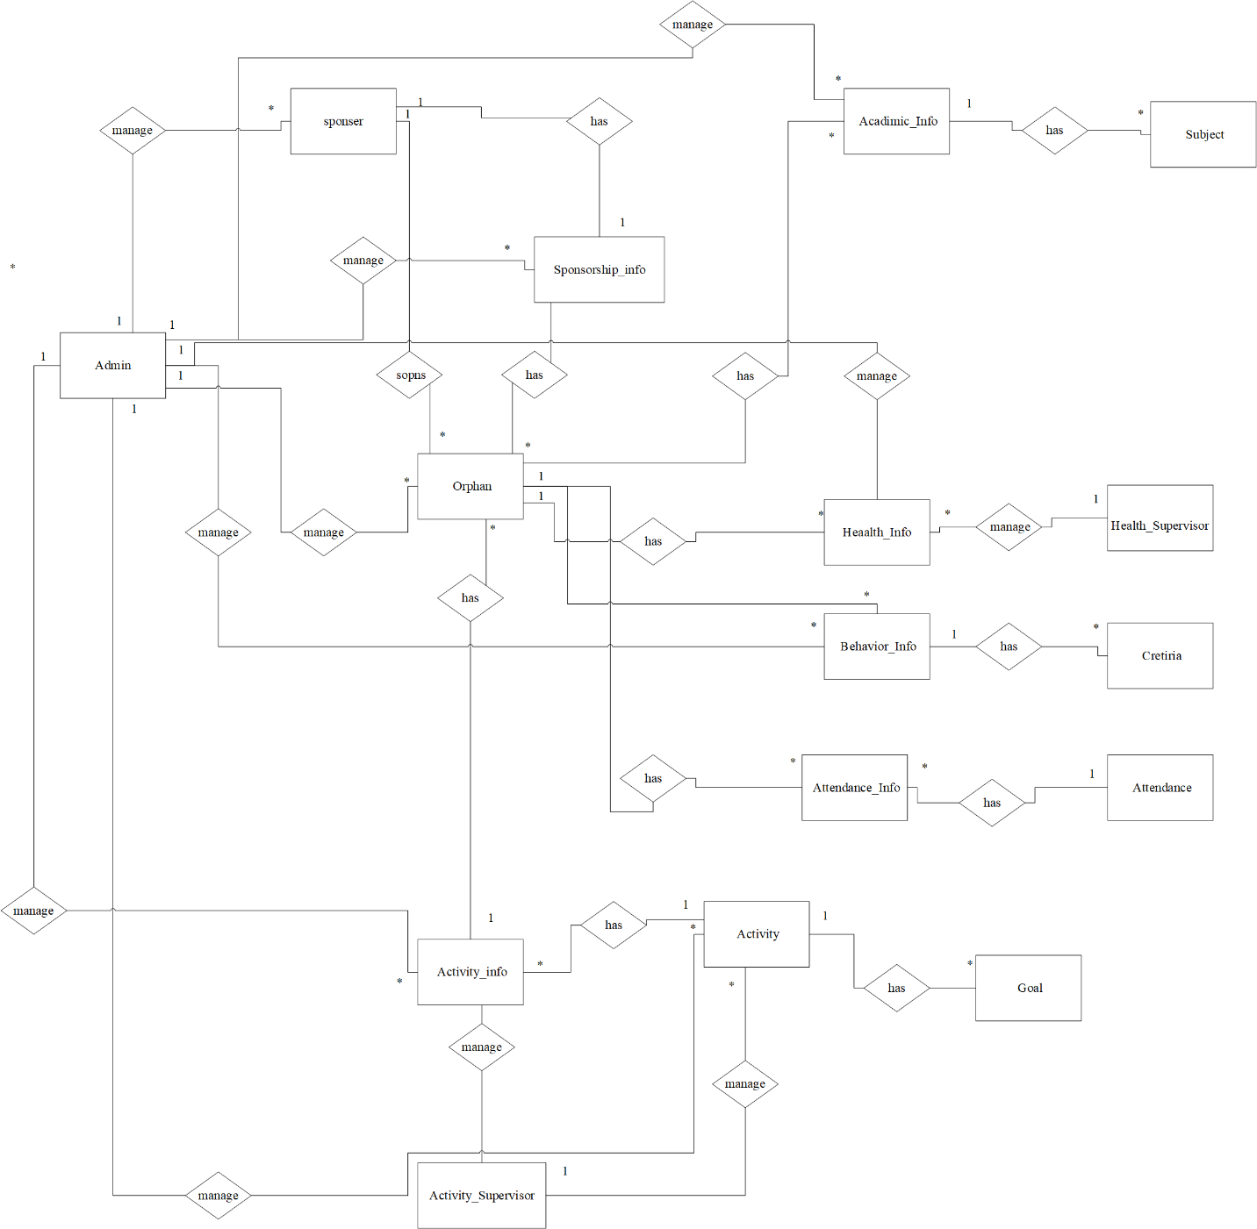

## Class Diagram

## Data Dictionary

### Table User

### Table Boarding House Supervisor

## Sequence diagram